Session 2 - 1

import java.io.*;
import java.util.*;

class Singleton {
private static volatile Singleton instance;
public String str;

private Singleton() {
}

public static Singleton getSingleInstance() {
if (instance == null) {
synchronized (Singleton.class) {
if (instance == null) {
instance = new Singleton();
}
}
}
return instance;
}
}

public class Solution {
public static void main(String[] args) {
Scanner scan = new Scanner(System.in);
if (scan.hasNextLine()) {
String input = scan.nextLine();
Singleton singleton = Singleton.getSingleInstance();
singleton.str = input;
System.out.println("Hello I am a singleton! Let me say " + singleton.str + " to you");
}
}
}

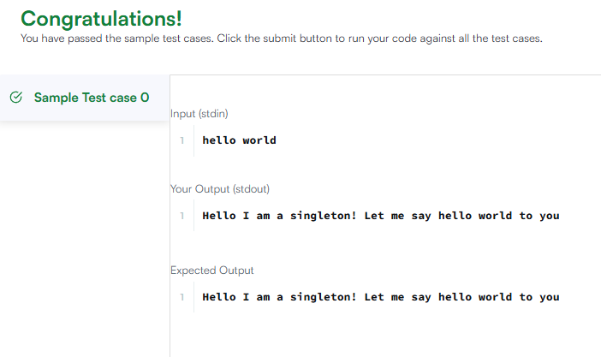

Session 2 -2

import java.util.ArrayList;
import java.util.HashMap;
import java.util.Map;
import java.util.Scanner;
import java.util.Stack;

enum Color {
RED, GREEN
}

abstract class Tree {
private int value;
private Color color;
private int depth;

public Tree(int value, Color color, int depth) {
this.value = value;
this.color = color;
this.depth = depth;
}

public int getValue() {
return value;
}

public Color getColor() {
return color;
}

public int getDepth() {
return depth;
}

public abstract void accept(TreeVis visitor);
}

class TreeNode extends Tree {
private ArrayList<Tree> children = new ArrayList<>();

public TreeNode(int value, Color color, int depth) {
super(value, color, depth);
}

public void accept(TreeVis visitor) {
visitor.visitNode(this);
for (Tree child : children) {
child.accept(visitor);
}
}

public void addChild(Tree child) {
children.add(child);
}
}

class TreeLeaf extends Tree {
public TreeLeaf(int value, Color color, int depth) {
super(value, color, depth);
}

public void accept(TreeVis visitor) {
visitor.visitLeaf(this);
}
}

abstract class TreeVis {
public abstract int getResult();
public abstract void visitNode(TreeNode node);
public abstract void visitLeaf(TreeLeaf leaf);
}

class SumInLeavesVisitor extends TreeVis {
private int sum = 0;

public int getResult() {
return sum;
}

public void visitNode(TreeNode node) {
}

public void visitLeaf(TreeLeaf leaf) {
sum += leaf.getValue();
}
}

class ProductRedNodesVisitor extends TreeVis {
private long product = 1;
private final int MOD = 1000000007;

public int getResult() {
return (int) product;
}

public void visitNode(TreeNode node) {
if (node.getColor() == Color.RED) {
product = (product * node.getValue()) % MOD;
}
}

public void visitLeaf(TreeLeaf leaf) {
if (leaf.getColor() == Color.RED) {
product = (product * leaf.getValue()) % MOD;
}
}
}

class FancyVisitor extends TreeVis {
private int nonLeafEvenDepthSum = 0;
private int greenLeavesSum = 0;

public int getResult() {
return Math.abs(nonLeafEvenDepthSum - greenLeavesSum);
}

public void visitNode(TreeNode node) {
if (node.getDepth() % 2 == 0) {
nonLeafEvenDepthSum += node.getValue();
}
}

public void visitLeaf(TreeLeaf leaf) {
if (leaf.getColor() == Color.GREEN) {
greenLeavesSum += leaf.getValue();
}
}
}

public class Solution {

static class NodeConfig {
int id;
int depth;
NodeConfig(int id, int depth) {
this.id = id;
this.depth = depth;
}
}

public static Tree solve() {
Scanner sc = new Scanner(System.in);
if (!sc.hasNextInt()) return null;

int n = sc.nextInt();

int[] values = new int[n + 1];
for (int i = 1; i <= n; i++) {
values[i] = sc.nextInt();
}

Color[] colors = new Color[n + 1];
for (int i = 1; i <= n; i++) {
colors[i] = (sc.nextInt() == 0) ? Color.RED : Color.GREEN;
}

ArrayList<Integer>[] adj = new ArrayList[n + 1];
for (int i = 1; i <= n; i++) {
adj[i] = new ArrayList<>();
}

for (int i = 0; i < n - 1; i++) {
int u = sc.nextInt();
int v = sc.nextInt();
adj[u].add(v);
adj[v].add(u);
}
sc.close();

if (n == 1) {
return new TreeLeaf(values[1], colors[1], 0);
}

Map<Integer, ArrayList<Integer>> treeStructure = new HashMap<>();
int[] depths = new int[n + 1];
boolean[] visited = new boolean[n + 1];

Stack<NodeConfig> stack = new Stack<>();
stack.push(new NodeConfig(1, 0));
visited[1] = true;

while (!stack.isEmpty()) {
NodeConfig curr = stack.pop();
depths[curr.id] = curr.depth;

ArrayList<Integer> childrenList = new ArrayList<>();
for (int neighbor : adj[curr.id]) {
if (!visited[neighbor]) {
visited[neighbor] = true;
childrenList.add(neighbor);
stack.push(new NodeConfig(neighbor, curr.depth + 1));
}
}
treeStructure.put(curr.id, childrenList);
}

Tree[] nodes = new Tree[n + 1];
for (int i = 1; i <= n; i++) {
if (treeStructure.get(i).isEmpty()) {
nodes[i] = new TreeLeaf(values[i], colors[i], depths[i]);
} else {
nodes[i] = new TreeNode(values[i], colors[i], depths[i]);
}
}

for (int i = 1; i <= n; i++) {
if (nodes[i] instanceof TreeNode) {
TreeNode parentNode = (TreeNode) nodes[i];
for (int childId : treeStructure.get(i)) {
parentNode.addChild(nodes[childId]);
}
}
}

return nodes[1];
}

public static void main(String[] args) {
Tree root = solve();
SumInLeavesVisitor visitor1 = new SumInLeavesVisitor();
ProductRedNodesVisitor visitor2 = new ProductRedNodesVisitor();
FancyVisitor visitor3 = new FancyVisitor();

root.accept(visitor1);
root.accept(visitor2);
root.accept(visitor3);

System.out.println(visitor1.getResult());
System.out.println(visitor2.getResult());
System.out.println(visitor3.getResult());
}
}

